Key Project Information & VPA Design Document (VPA DD)

PUBLICATION DATE 14.04.2023
VERSION v. 2.1
RELATED SUPPORT

- Programme of Activity requirements
- TEMPLATE GUIDE VPA Design Document v.2.1

This document contains the following Sections

Section A – Description of project
Section B - Application of approved Gold Standard Methodology (ies) and/or demonstration of SDG Contributions
Section C – Duration and crediting period
Section D – Summary of Safeguarding Principles and Gender Sensitive Assessment
Section E – Summary of Local stakeholder consultation
Section F - Eligibility and inclusion criteria for VPAs inclusion

Appendix 1 – Safeguarding Principles Assessment (mandatory)
Appendix 2- Contact information of VPA Implementer (mandatory)
Appendix 3 – LUF Additional Information (VPA specific)
Appendix 4 - Design Changes

KEY PROJECT INFORMATION
Type of VPA | ☐ Real case VPA  ☐ Regular VPA  ☒ VPA/CPA
Scale of VPA  Note that a VPA can be of one scale. Please select applicable scale accordingly. | ☐Microscale  ☒Small scale  ☐Large scale
Title of corresponding real case VPA (if applicable) | N/A
GS ID of real case VPA  (if applicable) | N/A
GS ID of VPA | GS11205
Title of VPA | GS7591 VPA 46 Improved Cookstove Distribution in Kayonza, Bugesera and Nyamasheke Districts of Rwanda (GS11205)
Time of First Submission Date | 10/08/2021
Date of Design Certification | 22/08/2023
Version number of the VPA-DD | 8
Completion date of version | 29/08/2023
Coordinating/managing entity | CO2blance UK Ltd.
VPA Implementer (s) | CO2balance UK Ltd.
Project Participants and any communities involved | Rwandans for Peace and Progress (RPP)
Host Country (ies) | Republic of Rwanda
GS ID and Title of applicable Design Certified VPA | N/A
GS ID and Title of applicable Performance Certified VPA | N/A
Activity Requirements applied | ☒ Community Services Activities  ☐ Renewable Energy Activities  ☐ Land Use and Forestry Activities/Risks & Capacities  ☐ N/A
Other Requirements applied | N/A
Methodology (ies) applied and version number | TPDDTEC v3.1
Product Requirements applied | ☒ GHG Emissions Reduction & Sequestration  ☐ Renewable Energy Label  ☐ N/A
VPA Cycle: | ☒ Regular  ☐ Retroactive

Table 1 – Estimated Sustainable Development Contributions

SUSTAINABLE DEVELOPMENT GOALS TARGETED | SDG IMPACT  (DEFINED IN B.6.) | ESTIMATED ANNUAL AVERAGE | UNITS OR PRODUCTS
13 Climate Action (mandatory) | Emission reductions | 34,199 | Number
3 Good Health and Wellbeing | Total reduction in household air pollution | 20% | %
5 Gender Equality | Total reduction time spent collecting fuel and cooking | 22% | %
7 Affordable and Clean Energy | Project ICS active | 15,360 | Number

- DESCRIPTION OF PROJECT
  - Purpose and general description of project
>>
This project involves the distribution and installation of approximately 32,000 fuel-efficient improved cookstoves (ICS) within households in the Kayonza, Bugesera and Nyamasheke Districts of Rwanda. The ICS distributed under this project will be the single pot, in-situ Canarumwe stove, which will be built into domestic kitchens.

The purpose of the Project is to reduce greenhouse gas emissions at a household level through the distribution of improved cookstoves which reduce wood consumption. As well as reducing greenhouse gas emissions, the Project will provide various benefits to the end user households and communities whilst helping to meet the UN Sustainable Development Goals (SDG) targets. Benefits include improved health through reduction in indoor air pollution, saving women time on unpaid chores, and reducing the income expenditure on fuelwood for stove recipients. The SDG impacts of the distribution of efficient cook stoves will be explored at greater detail, in later sections.

Biomass, principally firewood, holds huge importance in Rwanda, accounting for at least 79% of energy consumption. Wood fuel is in particularly high demand, especially in rural areas where 98% of households rely on wood as their main cooking fuel. Traditionally, families in the Kayonza District cook using a three-stone open fire. This method is inefficient and leads to the unsustainable usage of non-renewable biomass in the cooking process. The replacement fuel-efficient stove can lead to an annual saving between 25-65% per stove per household when used correctly.

The estimated average annual GHG emission reduction from this VPA is 34,199 tCO2e and the total GHG emission reduction estimated for the whole crediting period from the project activity is 170,996 tCO2e.
    - Eligibility of the VPA under approved PoA
>>
Table 2 Eligibility for VPA inclusion as per PoA requirements

No. | Eligibility Criterion | Description/  Required condition |  |  | DESCRIPTION OF THE VPA IN RELATION TO THE CRITERIA,  MEANS OF VERIFICATION AND SUPPORTING EVIDENCE  FOR INCLUSION
1 | Types of Project | Eligible Projects shall include physical action/implementation on the ground. |  |  | Projects will involve the distribution of improved cookstoves within the Kayonza, Bugesera and Nyamasheke Districts in Rwanda.  Project types are eligible under Community Services Activity Requirements s.3.1.1(b) and s3.1.1(d).
2 | Location of Project | Projects may be located in any part of the world. |  |  | The VPA is in the Kayonza, Bugesera and Nyamasheke Districts in Rwanda, as specified in Section A.4.4 of this document. Rwanda is one of the countries outlined in the PoA-DD. The VPA is uniquely defined by a range of GPS coordinates and current administrative maps to define the project boundary
3 | Project Area, Project Boundary and Scale | The Project Area and Project Boundary shall be defined. Projects may be developed at any scale although certain rules, requirements and limitations may apply under specific Activity Requirements, Impact Quantification Methodologies and Products Requirements.  In order to avoid double counting the Project shall not be included in any other voluntary or compliance standards programme unless approved by Gold Standard (for example through dual certification). Also, if the Project Area overlaps with that of another Gold Standard or other voluntary or compliance standard programme of a similar nature, the project shall demonstrate that there is no double counting of impacts at design and performance certification (for example use of similar technology or practices through which the potential arises for double counting or misestimation of impacts amongst projects). |  |  | The project boundary, including GPS co-ordinates and maps are included in Section B.3.  This VPA is not included by any other carbon standard and will be capped at an energy output of 60Gwh (180GWhth) per year as per CDM small-scale requirements.  The project will ensure it does not overlap with the GS1247 Kayonza district borehole project, by not implementing stoves in cells which borehole projects are located in.
4 | Host Country Requirements | Projects shall be in compliance with applicable Host Country’s legal, environmental, ecological and social regulations. |  |  | The Project Activity does not violate any of the Host Country’s legal, environmental, ecological  and social regulations. The  Project Activity reduces firewood consumption, which is in line with local forest harvesting regulations; and the economic empowerment of local cooperatives, who will manufacture the stoves.
5 | Contact Details | As part of the Project Documentation the Project Developer shall provide  (i) name and (ii) contact details of all Project Participants; AND in case of an organisation (iii) the legal registration details and (iv) documentation by the governing jurisdiction that proves that the entity is in good standing (defined as being a legal or other appropriate entity registered in or allowed to operate within the required jurisdiction and with no evidence of insolvency or legal/criminal notices placed against it or any of its Directors). Gold Standard retains the right (at its own discretion) to refuse use of the Standard where reputational concerns are highlighted. |  |  | Contact details of the Project  Developer and project implementor are included in  Appendix 1.
6 | Legal Ownership | Full and uncontested legal ownership of any Products that are generated under Gold Standard Certification, (for example carbon credits) shall be demonstrated. Where such ownership is transferred from project beneficiaries this must be demonstrated transparently and with full, prior and informed consent (FPIC). Note that for certain Project types there is a requirement for full and uncontested legal land title/tenure to be demonstrated. These are contained within specific Activity or Product Requirements. All projects shall immediately report to Gold Standard any land title/tenure disputes arising. |  |  | In exchange for the Project stove, users agree to the transfer of carbon rights and sign a Carbon Transfer Form.
7 | Other Rights | As well as legal title and ownership, the Project Developer shall also demonstrate where required uncontested legal rights and/or permissions concerning changes in use of other resources required to service the Project (for example, access rights, water rights etc.). Any known disputes or contested rights must be declared immediately to Gold Standard by the Project Developer and resolved prior to further Project implementation in affected areas. |  |  | There are no disputes or  contested rights that have been  identified in relation to rights  relevant to the project activity
8 | Official Development Assistance (ODA) Declaration | All Project Developers applying for project activities located in a country named by the OECD Development Assistance Committee’s ODA recipient list and seeking Gold Standard Certification for carbon credits shall declare the Official Development Assistance (ODA) support. The Project Developer shall follow the GHG Emissions Reduction & Sequestration Product Requirements and submit the declaration at the time of Design Certification. |  |  | A declaration confirming that  there is no diversion of ODA has  been submitted
9 | Fraction of Non-Renewable Biomass |  | Reference from where fNRB shall be calculated for VPAs shall be included in the eligibility criteria to avoid confusion at the time of VPA inclusion and for consistency | The fNRB is a national value obtained from an internal assessment using TOOL30 Methodological Tool: Calculation of the fraction of non-renewable biomass Version 04.0 for 2022. The calculation was completed 09/05/2023.
10 | Start Dates |  | Conditions to check the start dates of VPAs through documentary evidence. | The start date of this VPA is 24/08/2021. This will be evidenced by a carbon transfer form provided during the first verification review.
11 | Applicability |  | Conditions to ensure compliance with the applicability of the applied methodologies, the applied standardized baselines and the other applied methodological regulatory documents. | The methodology applied is Technologies and Practices to Displace Decentralized Thermal Energy Consumption V3.1. Compliance to applicability of methodology has been outlined in Section B.2 in the VPA-DD.
12 | Additionality |  | Conditions to ensure that VPAs meet the requirements for demonstration of additionality. | This VPA is automatically additional due to inclusion on the Positive List (annex B of CSA Requirements v1.2). Compliance to requirements for demonstration of additionality has been provided in section B.5 of this VPA-DD.
13 | LSC and EIA |  | Conditions related to undertaking local stakeholder consultation and environmental impact analysis. | The physical LSCs were conducted in June 2021 and September 2022 for this VPA. The stakeholder feedback round was conducted between September and October 2021. The LSC process was conducted in line with GS Stakeholder Consultation and Engagement Requirements v1.2 and Stakeholder Consultation and Engagement Guidelines v1.2. An EIA is not required as per the safeguarding principles.
14 | Target Group |  | Target group (e.g. domestic/commercial/industrial, rural/urban, grid-connected/offgrid), and where applicable, distribution mechanisms (e.g. direct installation). | The target group are domestic households in rural areas in the Kayonza, Bugesera and Nyamasheke districts in Rwanda who primarily use a three stone fire.
15 | Sampling |  | Sampling approaches are set out in each VPA and will follow the TPDDTEC v3.1 methodology. | The VPAs apply TPDDTEC v3.1 and follow the sampling approach set out in the methodology and CDM guidelines.
18 | Crediting Period |  | All VPAs submitted for inclusion after the first crediting cycle of such PoA and completion of transition to GS4GG shall follow the GS4GG Certification Cycle (i.e. 5 years renewals. | The crediting period for this VPA is 5 years long (twice renewable), from 24/08/2021 until 23/08/2026, as per GS4GG certification cycle.

Eligibility criteria as per section 2 and 3 of Community Services Activity Requirements v1.2:

No. | Eligibility Criterion | Description/  Required condition | Means of Verification/Supporting evidence  for inclusion
2.1.2 | Eligibility Project Types | All CSA Projects shall lead to climate change mitigation and/or  adaptation by providing or improving access to services/resources at the  household or community1 or institution2 level. Eligible services include  electricity and energy, water and sanitation, waste management,  housing, etc. | By distributing improved cookstoves, the project reduces household firewood consumption. The fuel-efficient project stove displaces the baseline technology – 3-stone fire with an estimated thermal efficiency of 10%. This leads to a reduction in firewood use and reduced CO2 emissions at a household/community level. As such, the project is an Eligible Project Type in line with the requirements.
2.1.3 | Eligibility Project Types | Projects shall conform to the Principles and Requirements. | The project conforms with the Principles and Requirements detailed in the document.  The project is eligible under section 4, Principle 1, section (a) of the Principles and Requirements as it follows an established Gold Standard methodology. Concerning point 4.1.7, the project does not support geoengineering or entail energy production from fossil fuels or nuclear. Rather it supports a switch away from polluting technologies to an emissions-free means of accessing safe water.
3.1.1 | Types of project | b) End-Use Energy Efficiency: Project activities that reduce energy requirements as compared to baseline scenario without affecting the level and quality of services or products where the end user of the products and services are clearly identified and when the physical intervention is required at the user end. | By distributing improved cookstoves, the project activity reduces the energy requirements compared to the baseline scenario by improving the efficiency of the stoves in rural households.
3.1.2 | Project area, boundary and scale | Project Area and Boundary shall be defined in line with the applicable Impact Quantification Methodologies and Product Requirements.  c) For the purpose of applying UNFCCC methodologies for quantification of GHG reductions, ‘small-scale’ is defined as in CDM Modalities and Procedures for three project types; Renewable Energy, Energy Efficiency and Others. | The project Area and Boundary are defined in line with the applicable Methodology, outlined in Section A.4.4.  The project is a Small-scale project issuing emission reductions which will be capped at the maximum savings equivalent of 60GWh per year.
3.1.3 | Suppressed Demand baseline | Certain Impact Quantification methodologies allow projects to account Suppressed Demand scenario when establishing a baseline. In such cases, the application of Supressed Demand baseline is limited to Small-Scale and Microscale Projects.  Where a Supressed Demand baseline is applied, it is not possible to ‘stack’ Gold Standard Certified Impact Statements or Products as the definition of the baseline may be contradictory. | This VPA and homogenous VPAs do not use a supressed demand baseline.  No Gold Standard Certified Impact Statements or Products are intended to be stacked in case of suppressed demand baseline.
3.1.4 | Legal ownership | a) Projects involving the distribution of a large number of devices for services shall provide a clear description of the ownership of the Products that are generated under Gold Standard Certification all along the investment chain. In line with FPIC requirement, the proofs that end-users are aware of and willing to give up their rights on Products shall be provided.  b) The transfer for Product ownership shall be discussed during the local stakeholder consultations for projects. | a) It will be clearly communicated that CO2balance is the Co-ordinating/Managing Entity which communicates with the Gold Standard and the entity that is claiming ownership rights of and selling the emission reductions resulting from the project activity. The project is managed in the host country by CO2balance. CO2balance have legal ownership of the carbon credits produced as a result of the project.  b) The transfer of ownership was discussed during the local stakeholder consultation conducted by CO2balance, presenting the details of the project to the local community members, officials and Community Leaders who attended. No issues were raised during the meeting voicing issues regarding the transfer of product ownership.

    - Legal ownership of products generated by the VPA and legal rights to alter use of resources required to service the project
>>
The legal ownership is with CO2balance UK Ltd. During the distribution of ICS, the participating household will sign a declaration to transfer the ownership rights of the carbon assets generated from this project to the project proponent.

The ICS are distributed to users for free. End users are informed in advance that the use of ICS generates carbon finance which in turn is used to cover the price of ICS and for recovering project implementation costs. The participating household will sign a declaration to transfer ownership rights of the carbon assets generated from this project to CO2balance UK Ltd.
  - Location of VPA
>>
Project location will be geographic boundary of the Kayonza, Bugesera and Nyamasheke Districts, in the Republic of Rwanda as shown in Figure 1.

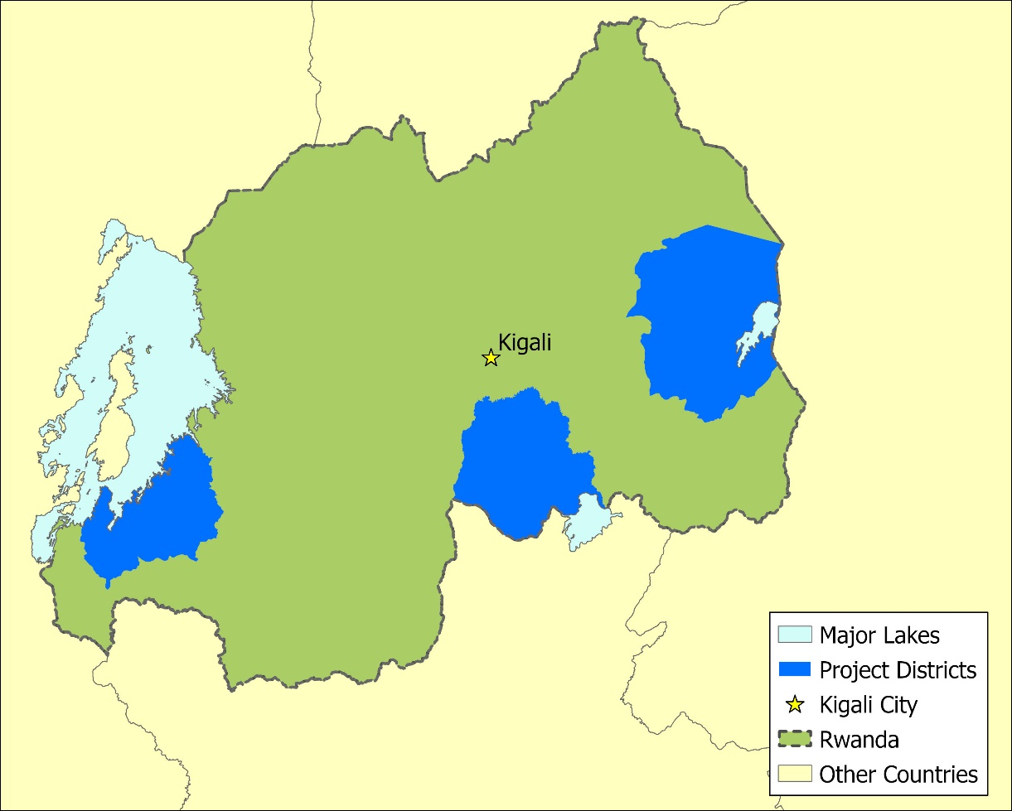
Figure 1 Project boundary is defined by the geographic borders of the Bugesera, Kayonza and Nyamasheke Districts, within Rwanda shown as the dark blue areas on the map. The map was created using ArcGIS Pro 2.9 and with the following data: Rwanda Administrative Boundary Data from OCHA ROSEA under the CC BY-IGO License (Non-endorsed) and the National Park Boundary, Towns and International Borders using OSM data under the ODb License. Please note that the boundaries are purely representative and real-life borders may vary.

The furthest most north, south, east, and west for each of the district are as follows (obtained from Google Earth®):
District | North | South | East | West
Kayonza | -1.599761, 30.638191 | -2.124726, 30.628124 | -1.655708, 30.837522 | -1.840881, 30.426369
Bugesera | -2.028618, 30.172867 | -2.434602, 30.137927 | -2.350549, 30.373034 | -2.326483, 29.959467
Nyamasheke | -2.150804, 29.246796 | -2.569045, 29.037774 | -2.359908, 29.343868 | -2.438549, 28.965040

  - Technologies and/or measures
>>
The project will distribute the Canarumwe Stove. This is a single pot, ceramic stove which is integrated into a mud hearth within the household’s kitchen. It reduces heat loss and improves heat transfer and combustion efficiency when compared to the baseline. This results in decreased fuel use in comparison to the baseline situation, and thus reduces CO2 emissions. The stoves will be provided to households for free, and in return, the communities will contribute materials to enable the stove to be installed into the users’ kitchens.
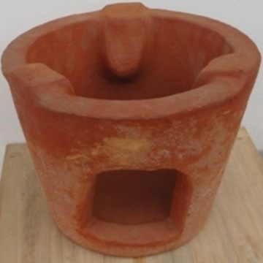  Figure 2 Canarumwe stove. Source: RPP | 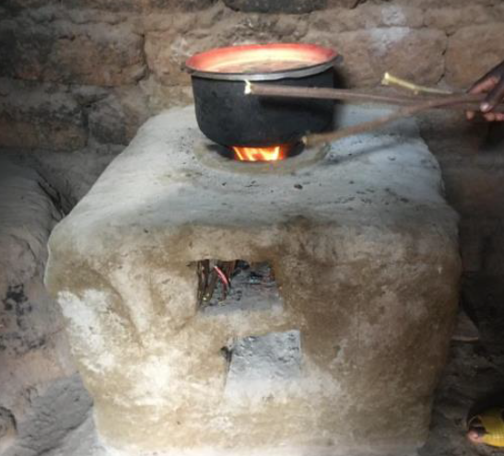  Figure 3 Canarumwe stove installed into mud hearth. Source: RPP
Key parameters:
Pot capacity | 20L
Lifetime | 5 years (PD assumes 3 years to be conservative)
Dimensions (l/w/h) | 190/300/210
Weight | 4KG
Shipping weight | 5KG
Characteristics/materials | Household, traditional clay, fixed or potable

The following table shows the measurable parameters of the Canarumwe stove:
Parameters | Value (Cm)
Top diameter | 28
Bottom diameter | 21.5
Combustion chamber top diameter | 21.5
Combustion chamber bottom diameter | 16
Pot rest height | 2
Pot rest extension to the stove | 10
Stove height above the ground | 21.5
Height of wood inlet | 11.5
Length of wood inlet | 10

The Canarumwe Stove is manufactured by the local cooperative HUGUKA MUBUMBYI factory and the Muhanga Improved Local Technologies factory and has an average lifespan of 5 years. However, to be conservative, the lifetime of the stove will be assumed to be 3 years.

The steps to create the Canarumwe Stove include:

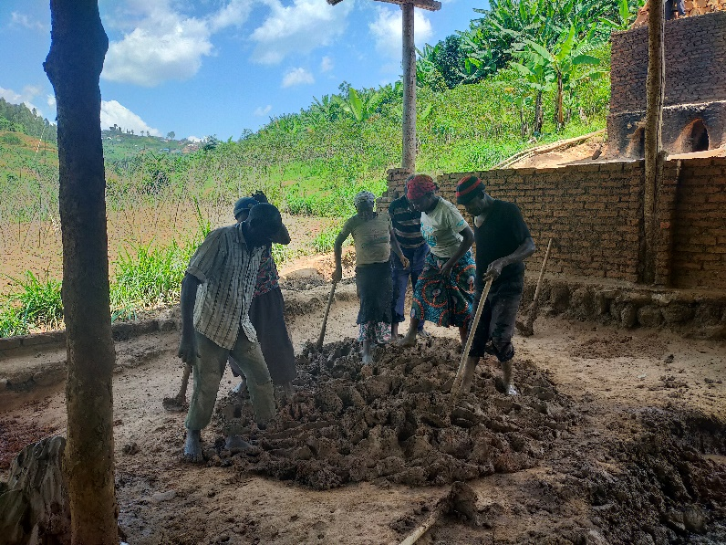  1. Clay and sand are mixed to create the basic material which is used to shape the stove. The clay is carefully processed and any material that could prevent the stove from being efficient is removed. | 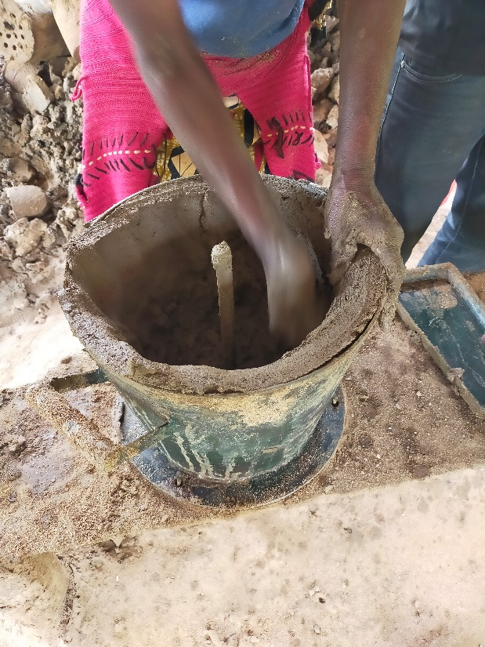  2. Next, the clay is shaped using a pre-shaped mould and dried for 2-3 days in a designated spot without sun or rain exposure.
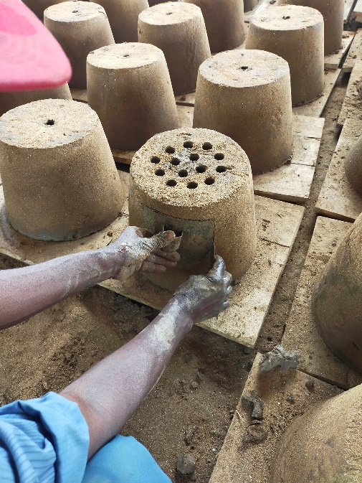  3. Once dried, next steps include the addition of the “entry” and the holes in the bottom of the stove by using a gauge to support the airflow. | 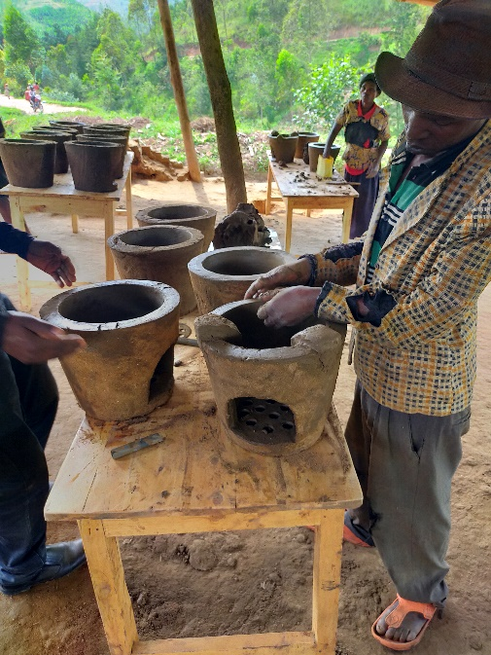  4. Afterwards, the three pot stands are added, again by working with a gauge. A unique serial ID is also gauged into the stove.
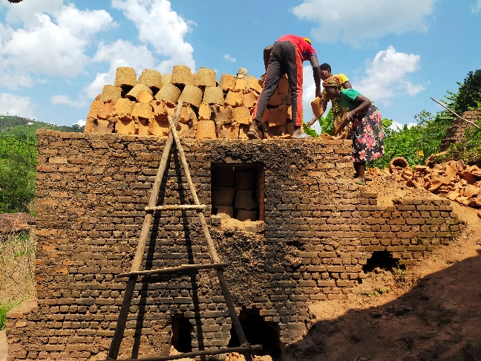 | 5. After air drying for more than 8 days, the stoves are burned in the kiln for at least 28 hours. The factory kiln can contain 720 stoves. It is only after this last stage that the Canarumwe stove can be described as “improved”.
  - Scale of the VPA
>> This is a small scale “type II” project as it focuses on “energy efficiency improvement project activities” and must not exceed the equivalent of 60 gigawatt hours per year every year. Therefore, the VERs are capped at 60,000 per year.
  - Funding sources of VPA
>> The project is funded entirely by CO2balance UK Ltd.

- APPLICATION OF APPROVED GOLD STANDARD METHODOLOGY (IES) AND/OR DEMONSTRATION OF SDG CONTRIBUTIONS
  - Reference of approved methodology (ies)
>> Methodology: Technologies and Practices to Displace Decentralized Thermal Energy Consumption V3.1
This project also refers to the approved versions of the following tools and methodologies:
- Requirements and Guidelines: Usage Rate Monitoring V2.0
- TOOL30: “Calculation of the fraction of non-renewable biomass”. Version 4.0
- CDM Guideline “Sampling and surveys of CDM project activities and programmes of activities”. Version 4.0
  - Applicability of methodology (ies)
>> The project is expressly applicable under section 1 of TPDDTEC v3.1.
Methodology Requirement | Project
1. ‘The project boundary can be clearly identified, and the technologies counted in the project are not included in another voluntary market or CDM project activity. | The project area (Kayonza, Bugesera and Nyamasheke Districts) has been clearly demonstrated using political boundaries recognised in Rwanda. Each technology will be individually tagged with an identification code which is stored securely in the project database. Regular project surveys together with distribution records will ensure that the technologies included in the project are not double counted.
2. Technologies have a continuous useful energy output of less than 150kW per unit (defined as total energy delivered usefully from start to end of operation of a unit divided by time of operation). For technologies or practices that do not deliver thermal energy in the project scenario but only displace thermal energy supplied in the baseline scenario, the 150kW threshold applies to the displaced baseline technology. | The estimated energy output of the project stove is 4.19 Kw which is well within the methodological limit of 150kw.
3. The use of the baseline technology as a backup or auxiliary technology in parallel with the improved technology introduced by the project activity is permitted as long as a mechanism is put into place to encourage the removal of the old technology and the definitive discontinuity of its use. | As noted in the Gold Standard Methodology p.5. ‘the removal and continued non-use of three stone fires and other easily constructed traditional devices (the baseline technology replaced by this project activity) is in many cases unlikely and impractical to monitor.’  The project stove is given to users, however they must provide materials to fit it in their kitchen, so they see some benefit in using it over the three-stone fire, such as saving on wood costs, saving time on wood collection, ability to move the stove, ease of use, and/or reduced smoke. Therefore, households are unlikely to use the baseline three-stone fire if they have invested materials in the project stove.
a) The project documentation must provide a clear description of the approach chosen and the monitoring plan must allow for a good understanding of the extent to which the baseline technology is still in use after the introduction of the improved technology, whether the existing baseline technology is not surrendered at the time of the introduction of the improved technology, or whether a new baseline technology is acquired and put to use by targeted end users during the project crediting period. | Overall use of the baseline technology will be monitored in conjunction with that of the project technology, as will the emergence of any other baseline technology by targeted end users. As per the Methodology kitchen surveys will be carried out at regular intervals to determine any changes in baseline technology use.
b)‘’The success of the mechanism put into place must therefore be monitored, and the approach must be adjusted if proven unsuccessful. If an old technology remains in use in parallel with the improved technology, corresponding emissions must of course be accounted for as part of the project emissions.’’ | Parallel baseline technology use (three stone fires) will be revealed during monitoring and its effect on emissions reductions will be captured in the KPT and usage surveys. The uptake rate U will also be determined by surveys and hence used to account for parallel baseline and project technology use.
4. The project proponent must clearly communicate to all project participants the entity that is claiming ownership rights of and selling the emission reductions resulting from the project activity. This must be communicated to the technology producers and the retailers of the improved technology or the renewable fuel in use in the project situation by contract or clear written assertions in the transaction paperwork. If the claimants are not the project technology end users, the end users should be notified that they cannot claim for emission reductions from the project. | This was explained in detail at the LSC and will be clearly communicated to purchases at the point of instalment. It is also detailed in the warranty card received at the point of instalment.
5. Project activities making use of a new biomass feedstock in the project situation (e.g. shift from non-renewable to green charcoal, plant oil or renewable biomass briquettes) must comply with relevant Gold Standard specific requirements for biomass related project activities, as defined in the latest version of the Gold Standard rules. | As the technology used in this project has been specifically designed to displace baseline feedstock use via fuelwood, rather than a new biomass feedstock, this criterion is not applicable to this project. The emission reductions from this project will result from a change in quantity of fuel consumed, rather than change of fuel type.
a) Adequate evidence is supplied to demonstrate that indoor air pollution (IAP) levels are not worsened compared to the baseline, and greenhouse gases (as listed in section 2.1) emitted by the project fuel/stove combination are estimated with adequate precision. The project fuel/stove combination may include instances in which the project stove is a baseline stove. | The fuel used in both the project and baseline scenario is the same, as such there are no additional harmful gases released in the project scenario. The baseline technology has also not changed; rather its use for boiling will have been eliminated.
b) Records of renewable fuel sales may not be used as sole parameters for emission reduction calculation, but may be used as data informing the equations in section 2.0 of this methodology if correlated to data on distribution and results of field tests and surveys confirming (a) actual use of the renewable fuel and usage patterns such as average fraction of non-renewable fuels used in mixed combustion or seasonal variation of fuel types, (b) GHG emissions, (c) evidence of CO levels not deteriorating (d) any further factors effecting emission reductions significantly. | Renewable fuels are not sold as part of this project therefore this point is not applicable.

  - VPA boundary
>>
As the activity involves distribution of ICS, the project boundary is the physical, geographical location of each household where the ICS is distributed to replace the traditional stove (within the geographical boundaries of the Kayonza, Bugesera and Nyamasheke districts of the Republic of Rwanda).
A representation of the baseline boundary and project boundary are given below.
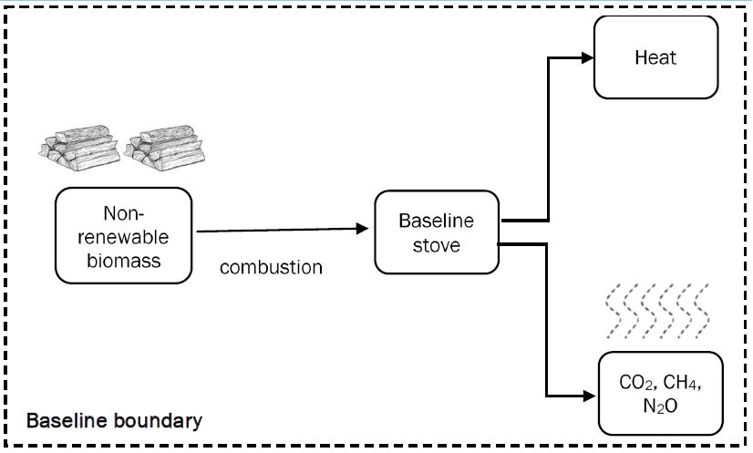
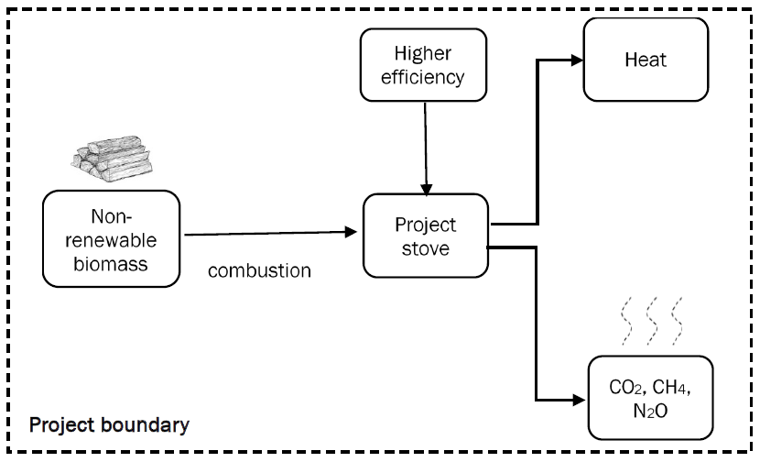
The greenhouse gases included in the project boundary are shown in the table below:

Source |  | GHGs | Included? | Justification/Explanation
Baseline scenario | Combustion of firewood | CO₂ | Yes | Important source of emissions
 |  | CH₄ | Yes | Important source of emissions
 |  | N₂O | Yes | Gas included in the calculations. Emissions factors for fuel in stationery combustion by the IPCC.
 |  | …
Project scenario | Combustion of firewood | CO₂ | Yes | Important source of emissions
 |  | CH₄ | Yes | Important source of emissions
 |  | N₂O | Yes | Gas included in the calculations. Emissions factors for fuel in stationery combustion by the IPCC.
 |  | …

  - Establishment and description of baseline scenario
>>
Two types of surveys have been conducted to properly capture the baseline scenario in the project area: the Baseline Kitchen Performance Test (KPT) and the baseline Kitchen Survey (KS). Both are conducted at a household level.
1) The Baseline Kitchen Survey is a qualitative assessment of demographic indicators, cooking habits, cookstove usage and seasonality that is conducted at project level.
2) The Baseline Kitchen Performance Test, was completed prior to implementation of project activity to establish the estimation of average annual fuel consumption per household in absence of project activity.
Baseline Kitchen Survey
The Kitchen Survey is a detailed questionnaire designed to identify cooking habits, demographic and socio-economic characteristics. In-line with Gold Standard requirements, the Kitchen Survey provides critical information on target population characteristics, fuel consumption for cooking use and leakage. According to the relevant Gold Standard methodology the following information was captured in the surveys:
- Address or location
- Telephone number (when possible)
- Socio-Demographic Characteristics
- Number of people served by baseline technology
- Typical baseline technology usage patterns and tasks (commercial, institutional, domestic etc)
- Types of baseline technology used and estimated frequency
- Types of fuels used and estimated quantities
- Seasonal variations in baseline technology and fuel use
- Sources of fuels and prices paid or effort made
The kitchen survey was conducted across the Kayonza, Bugesera and Nyamasheke districts in Rwanda. 120 surveys were conducted in Kayonza between 29 - 31/03/2021. 235 surveys were conducted in Bugesera and 234 in Nyamasheke district between 27/07/2022 and 21/09/2022.
Baseline Kitchen Performance Test
A Baseline Kitchen Performance Test (KPT) was carried out in representative households to assess the daily consumption of fuel per household prior to project activity. A short introduction survey was administered to obtain basic data of each household and to instruct the participants not to modify their typical cooking habits.
Participants were visited over 4 days to measure the amount of fuel used on a normal day in their household. On the first day initial fuel stocks were weighed. Subsequently, fuel used within each household was weighed during consecutive days.
The KPT was conducted using two types of scales, the Weiheng portable electronic scales with 50kg max weight, dual accuracy: 0~10Kg / 5g, 10~50Kg / 10g, and the Weiheng WH-C 300kg Portable Plastic Electric Digital Hanging Scales with a 300KG maximum measurement range. The error range for this device is 0.01KG.
Project implementor RPP completed a calibration of all scales to be used during KPT prior to the activity. The calibration procedure involved the measurement of a standardised test weight by each scale to ensure the weights was the same across all scales. The enumerators were trained by RPP on how to conduct calibration of the scales prior to the activity starting. RPP then oversaw calibration throughout the four-day survey, each time the use or collect pile was weighed at households.
Quality assurance for the KPT included training of the enumerators prior to the activity on how to use the scales. The enumerators were also supervised throughout the 4-day survey by RPP. The scales were given new batteries, kept clean and well maintained to ensure accurate readings. Prior to each use, the enumerators turned the scales on and first waited until the scale showed 0.000 kg on the screen before proceeding.
The Baseline KPTs were conducted across the Kayonza, Bugesera and Nyamasheke districts in Rwanda. 60 surveys were conducted in Kayonza between 29 - 31/03/2021. 154 surveys were conducted in Bugesera and 155 in Nyamasheke district between 27/07/2022 and 21/09/2022.
Fuel use data was used to establish a baseline for the project area, Kayonza, Bugesera and Nyamasheke districts. The data has been averaged for each household and over the whole sample size.
Results
The baseline scenario is the continued use of non-renewable wood fuel (firewood) by the target population to meet similar thermal energy needs as provided by project cookstoves in absence of project activity.

The baseline kitchen survey indicated 92.5% of households in the project area were found to use a three-stone fire as the main cooking technology, with 5.6% using an improved wood stove and 1.5% using a charcoal stove. Additionally, 98% of households use wood as the main fuel, with limited households using charcoal (1.5%) and other fuel types (<1%). No seasonal variations were observed in baseline technology or fuel use.
The baseline KPT indicated the average use per day of wood fuel was 11.061 KG. Charcoal use was found to be insignificant.
  - Demonstration of additionality
>>
Specify the methodology, activity requirement or product requirement that establishes deemed additionality for the proposed project (including the version number and the specific paragraph, if applicable). | Gold Standard For the Global Goals Community Services Activity Requirements v1.2: Annex B – Positive List section 1.1.3.
Describe how the proposed project meets the criteria for deemed additionality. | Each unit results in an estimated 1.78 tonnes of emission reductions per year (please see analysis within the ex-ante calculations). This is less than the 600-tonne limit to meet additionality requirements.

    - Prior Consideration
>> N/A
    - Ongoing Financial Need
>> N/A
  - Sustainable Development Goals (SDG) outcomes
Relevant Target/Indicator for each of the three SDGs
Sustainable Development  Goals Targeted | Most relevant  SDG Target | SDG Impact
 |  | Indicator (Proposed or SDG Indicator)
3 - Ensure healthy lives and promote well-being for all at all ages | 3.9: By 2030, substantially reduce the number of deaths and illnesses from hazardous chemicals and air, water and soil pollution and contamination | HAPRy: total reduction in household air pollution for project activity in year y (%)
5- Achieve gender equality and empower all women and girls | 5.4 Recognize and value unpaid care and domestic work through the provision of public services, infrastructure and social protection policies and the promotion of shared responsibility within the household and the family as nationally appropriate  5.4.1 Proportion of time spent on unpaid domestic and care work, by sex, age and location | TRy: total reduction time spent collecting firewood and cooking for project activity in year y (%)
7 - Ensure access to affordable, reliable, sustainable and modern energy for all | 7.2: By 2030, increase substantially the share of renewable energy in the global energy mix | ICS_{a,y}: number of project ICS active in year y
13 Climate Action (mandatory) | N/A | Emissions Reductions

    - Explanation of methodological choices/approaches for estimating the SDG Impact
>> SDG 3 (Good Health and Wellbeing)
Switching from an unimproved stove to an improved cookstove reduces the volume of non-renewable biomass that needs to be burned for the household's daily cooking needs. Therefore, the reduction in non-renewable biomass burned can be taken as a proxy indicator of how these VPAs contribute towards the SDG 3 target of substantially reduce the number of deaths and illnesses from hazardous chemicals and air, water and soil pollution and contamination.
The average difference in fuel use per technology per day in the project will be subtracted from the baseline figure which comes from the Kitchen Performance test and is fixed throughout the crediting period. This difference will then be used to calculate the % decrease in fuel use, which is the figure used to calculate the VPAs' contribution to the SDG target.
The overall reduction in HAP by the project activity are then calculated as follows:
HAPR_{y} = ((P_{b,y} – P_{p,y}) / P_{b,y}) * U_{p,y}

Where:
HAPR_{y} Total reduction in Household Air Pollution for project activity in year y (%)
P_{b,y} Quantity of fuel that is consumed in the baseline scenario b during year y (kg/household-day)
P_{p,y} Quantity of fuel that is consumed in the project scenario p during year y (kg/household-day)
U_{p,y} Usage rate in project scenario p during year y

SDG 5 (Gender Equality)
The project aims to reduce the time poverty of women, because the time burden of cooking and collecting firewood, which falls disproportionately on women, will be reduced by the project stove. The stove reduces wood consumption, which means that women will spend less time collecting firewood, and its thermal efficiency also reduces cooking time, which reduces the time burden placed on women. The average % decrease per household in time spent collecting firewood will be taken as a proxy contribution towards the SDG target.
The overall reduction in time spent collecting firewood by the project activity are then calculated as follows:
TR_{y} = (T_{b,y} - T_{p,y}) / T_{b,y}
Where:
TR_{y} Total reduction time spent collecting firewood and cooking for project activity in year y (%)
T_{b,y} Time spent collecting firewood and cooking per household per day prior to project (hours)
T_{p,y} Time spent collecting firewood and cooking per household per day in project (hours)

SDG 7 (Affordable and Clean Energy)
The VPAs involve the distribution of ICS, a fuel-efficient technology, to replace the inefficient three stone fires. To measure 7 (Ensure access to affordable, reliable, sustainable, and modern energy for all), indicator 7.2 provides for the measurement of the ‘proportion of the population with primary reliance on clean fuels and technology’. The outcome for SDG 7 is quantified as the additional number of persons having access to efficient cookstove technology in the project activity and is calculated using parameters from the project scenario.

ICS_{a,y} = ICS_{t,y} * U_{p,y}
Where:
ICS_{a,y} Project ICS active in year y
ICS_{t,y} Project ICS distributed in year y
U_{p,y} Usage rate

SDG 13: Climate Action
The contribution to SDG 13 will be measured through carbon credits issued following the Gold Standard TPDDTEC v3.1 methodology.
The baseline fuel and project fuel are the same and the baseline emission factor and project emission are considered the same, therefore the overall GHG reductions are calculated by using equation 1 in the methodology:
Σ_{b,p} | Sum over all relevant (baseline b/project p) couples
N_{p,y} | Cumulative number of project technology-days included in the project database for project scenario p against baseline scenario b in year y
U_{p,y} | Usage rate in project scenario p during year y
P_{p,b,y} | Specific fuel savings for an individual technology of project p against an individual technology of baseline b in year y, in tons/day
f NRB_{,b, y} | Fraction of non-renewable biomass used in year y
NCV_{b,fuel} | Net calorific value of the fuel that is substituted or reduced (wood)
EF_{b,fuel,CO2} | CO₂ emission factor of the fuel that is substituted or reduced (wood)
EF_{b,fuel,nonCO2} | Non-CO₂ emission factor of the fuel that is reduced (wood)
LE_{p,y} | Leakage for project scenario p in year y (tCO₂e/yr)

Where:
P_{p,b,y =} P_{b,y} - P_{p,y}
P_{b,y} | Quantity of fuel that is consumed in baseline scenario b during year y
P_{p,y} | Quantity of fuel that is consumed in project scenario p during year y

    - Data and parameters fixed ex ante
SDG 13
Relevant SDG Indicator | SDG 13.B.1 (Climate Action), SDG 3.9.1 (Good Health and Well-Being)
Data/parameter | P_{b,y}
Unit | kg/household/day
Description | Quantity of fuel that is consumed in the baseline scenario b during year y (kg/household-day)
Source of data | Baseline Kitchen Performance Test  File name: Rwanda ICS Baseline KPT Final Results  Sheet: FINAL Total Results
Value(s) applied | 11.061 kg/HH/day
Choice of data or Measurement methods and procedures | Baseline Kitchen Performance Test carried out in line with the methodology.
Purpose of data | Calculation of baseline scenario
Additional comment | This parameter is also used for calculating SDG 3 indicator

Relevant SDG Indicator | SDG 13.B.1 (Climate Action)
Data/parameter | NCV_{b,fuel}
Unit | TJ/ton
Description | Net calorific value of the fuel that is substituted or reduced (wood)
Source of data | IPCC Default emissions factor
Value(s) applied | 0.0156
Choice of data or Measurement methods and procedures | Deemed valid by Methodology.
Purpose of data | Calculation of emission reductions.
Additional comment | -

Relevant SDG Indicator | SDG 13.B.1 (Climate Action)
Data/parameter | EF_{fuel,CO2}
Unit | tco₂/TJ
Description | CO2 emission factor of the fuel that is substituted or reduced (wood)
Source of data | IPCC Default Value for Wood fuel  Volume 2: 2006 IPCC Guidelines for National Greenhouse Gas Inventories, Chapter 2, Table 2.5
Value(s) applied | 112
Choice of data or Measurement methods and procedures | Deemed valid by Methodology.
Purpose of data | Calculation of emission reductions.
Additional comment | -

Relevant SDG Indicator | SDG 13.B.1 (Climate Action)
Data/parameter | EF_{fuel,nonCO2}
Unit | tCO₂e/TJ
Description | Non-CO₂ (CH₄ and N₂O) emission factor of the fuel that is reduced (wood)
Source of data | Default emissions factor:  https://www.ipcc-nggip.iges.or.jp/public/gp/bgp/2_2_Non-CO2_Stationary_Combustion.pdf  https://ghgprotocol.org/sites/default/files/ghgp/Global-Warming-Potential-Values%20%28Feb%2016%202016%29_1.pdf  Global Warming Potential: http://www.ipcc.ch/publications_and_data/ar4/wg1/en/ch2s2-10-2.html#table-2-14
Value(s) applied | 9.46
Choice of data or Measurement methods and procedures | Deemed valid by Methodology  Gas Default Emissions factor (kg_gas/TJ_{NCV}) GWP of gas Default Emissions factor (kg_CO₂e/TJ_{NCV}) Default Emissions factor (t_CO₂e/TJ_{NCV})  CH₄ 300 28 8,400 8.4000  N₂O 4 265 1,060 1.060  Total 9.46
Purpose of data | Calculation of emission reductions.
Additional comment | This value corresponds with updated AR5 GWP value linked above.  AR5 - https://www.ipcc.ch/site/assets/uploads/2018/02/WG1AR5_Chapter08_FINAL.pdf

Relevant SDG Indicator | SDG 13.B.1 (Climate Action)
Data/parameter | fNRB_{y}
Unit | Fraction
Description | Fraction of non-renewable biomass used in year y
Source of data | Internal fNRB Assessment. The fNRB value for this project has been calculated by using the CDM Tool30 v4.0 with FAO data. See “Rwanda fNRB Calculations” spreadsheet for calculations and “Rwanda fNRB Report” for full description of method and references.
Value(s) applied | 0.9
Choice of data or Measurement methods and procedures | Deemed valid by Methodology
Purpose of data | Calculation of emission reductions.
Additional comment | The project proponent may at any time choose to re-examine renewability by conducting a new NRB assessment.

SDG 5
Relevant SDG Indicator | SDG 5.4.1 (Gender Equality)
Data/parameter | T_{b,y}
Unit | Minutes
Description | Time spent collecting firewood and cooking per household per week prior to project in year y
Source of data | Baseline kitchen survey questions  Spreadsheet: GS11205 KBN Rwanda ICS - Baseline KS v1
Value(s) applied | 833 minutes
Choice of data or Measurement methods and procedures | Measured by the following questions in the baseline kitchen survey:  How much time is spent cooking per day during the dry season? (minutes)  How much time is spent cooking per day during the rainy season? (minutes)  On average, how long do you spend collecting fuel per trip?  On average, how many trips do you take to collect fuel for cooking per week?
Purpose of data | Calculating time saved collecting firewood and cooking by project.
Additional comment | -

    - Ex ante estimation of SDG Impact
>>
Summary of ex ante estimates of each SDG outcome
SDG 3:
Year | Baseline estimate | Project estimate | Net benefit
1: 2021-2022 | 0% total reduction in household air pollution | 27% total reduction in household air pollution | 27% total reduction in household air pollution
2: 2022-2023 | 0% | 26% | 26%
3: 2023-2024 | 0% | 24% | 24%
4: 2024-2025 | 0% | 15% | 15%
5: 2025-2026 | 0% | 9% | 9%
Total | NA | NA | NA
Total number of crediting years | 5
Annual average over the crediting period | 0% | 20% | 20%

SDG 5:
Year | Baseline estimate | Project estimate | Net benefit
1: 2021-2022 | 0% total reduction time spent collecting fuel and cooking | 34% total reduction time spent collecting fuel and cooking | 34% total reduction time spent collecting fuel and cooking
2: 2022-2023 | 0% | 28% | 28%
3: 2023-2024 | 0% | 22% | 22%
4: 2024-2025 | 0% | 16% | 16%
5: 2025-2026 | 0% | 10% | 10%
Total | NA | NA | NA
Total number of crediting years | 5
Annual average over the crediting period | 0% | 22% | 22%

SDG 7:
Year | Baseline estimate | Project estimate | Net benefit
1: 2021-2022 | 0 efficient stoves disseminated and operating | 18,000 efficient stoves disseminated and operating | 18,000 efficient stoves disseminated and operating
2: 2022-2023 | 0 | 27,200 | 27,200
3: 2023-2024 | 0 | 25,600 | 25,600
4: 2024-2025 | 0 | 6,000 | 6,000
5: 2025-2026 | 0 | 0 | 0
Total | 0 | 27,200 | 27,200
Total number of crediting years | 5
Annual average over the crediting period | 0 | 15,360 | 15,360

SDG 13:
Year | Baseline estimate | Project estimate | Net benefit
1: 2021-2022 | 35,624 tCO2e emitted | 0 tCO2e emitted | Emissions reduced by 35,624 tCO2e
2: 2022-2023 | 56,999 tCO2e emitted | 0 tCO2e emitted | Emissions reduced by 56,999 tCO2e
3: 2023-2024 | 56,999 tCO2e emitted | 0 tCO2e emitted | Emissions reduced by 56,999 tCO2e
4: 2024-2025 | 21,374 tCO2e emitted | 0 tCO2e emitted | Emissions reduced by 21,374 tCO2e
5: 2025-2026 | 0 tCO2e emitted | 0 tCO2e emitted | Emissions reduced by 0 tCO2e
Total | 170,996 tCO2e emitted | 0 tCO2e emitted | Emissions reduced by 170,996 tCO2e
Total number of crediting years | 5
Annual average over the crediting period | 34,199 tCO2e emitted | 0 tCO2e emitted | Emissions reduced by 34,199 tCO2e

  - Monitoring plan
    - Data and parameters to be monitored
SDG 13
Data / Parameter | N_{p,y}
Unit | Project Technology Days
Description | Cumulative number of project technology-days included in the project database for project scenario p against baseline scenario b in year y
Source of data | Ex-ante values have been estimated in the spreadsheet titled “GS11205 KBN Rwanda ICS - Ex-antes”, sheet “SDG13 Ex-antes”.  The source of the data for real emission reductions calculations for each monitoring period will be the Total Distribution Record which is compilation of all end-user Carbon Transfer Forms.
Value(s) applied | Estimated ex-ante values:  Year 1 7,300,000  Year 2 11,680,000  Year 3 11,680,000  Year 4 4,380,000  Year 5 0  The values applied in the ex-antes calculation are based on the estimated stove distribution per year multiplied by the number of days in each year (365).  The values for real emission reductions calculations will be monitored and calculated for each monitoring period.
Measurement methods and procedures | Sum of the total number of cookstoves distributed multiplied by the number of days crediting each technology earns in each monitoring period
Monitoring frequency | Continuous recording
QA/QC procedures
Purpose of data | Calculation of emission reductions
Additional comment | -

Data / Parameter | U_{p,y}
Unit | Percentage
Description | Usage rate in project scenario p through year y
Source of data | Ex-ante values have been estimated in the spreadsheet titled “GS11205 KBN Rwanda ICS - Ex-antes”, sheet “SDG13 Ex-antes”.  The source of the data for real emission reductions calculations for each monitoring period will be the Usage Survey
Value(s) applied | Estimated ex-ante value:  90%  The value for real emission reductions calculations will be monitored and calculated for each monitoring period.
Measurement methods and procedures | Usage Survey
Monitoring frequency | Measured annually
QA/QC procedures | The usage survey has been carried out by trained local staff to meet the specific requirements of the methodology. All data presented in excel is subject to checking and cross referencing of a sample of the raw data by CO2balance
Purpose of data | Calculation of project scenario
Additional comment | A single usage parameter is weighted to be representative of the quantity of project technologies of each age being credited in a given project scenario.  This parameter is also used for calculating SDG 3 & 7 indicator

Data / Parameter | P_{p,y}
Unit | Kg/household-day
Description | Quantity of fuel that is consumed in the project scenario p during year y (kg/household-day)
Source of data | Ex-ante values have been estimated in the spreadsheet titled “GS11205 KBN Rwanda ICS - Ex-antes”, sheet “SDG13 Ex-antes”.  The source of the data for real emission reductions calculations for monitoring periods will be the biennial project Kitchen Performance Test
Value(s) applied | Estimated ex-ante value:  7.74  The value for real emission reduction calculations will be calculated for each monitoring period.
Measurement methods and procedures | Calculating quantity of fuel used in the project scenario using the KPT survey
Monitoring frequency | Measured biennially
QA/QC procedures
Purpose of data | Calculation of emission reductions
Additional comment | This parameter is also used for calculating SDG 3 indicator

Data / Parameter | P_{p,b,y}
Unit | tonne/household-day
Description | Specific fuel savings for an individual technology of project p against an individual technology of baseline b in year y, in tons/day
Source of data | Ex-ante value has been estimated in the spreadsheet titled “GS11205 KBN Rwanda ICS - Ex-antes”, sheet “SDG13 Ex-antes”.  The source of this calculated parameter will be the applicable monitoring period emission reduction calculation spreadsheet.
Value(s) applied | Estimated ex-ante value:  0.0033  The value for real emission reduction calculations will be calculated for each monitoring period.
Measurement methods and procedures | Calculated from fixed parameter P_{b,y} and monitored parameter P_{p,y}
Monitoring frequency | Calculated biennially
QA/QC procedures
Purpose of data | Calculation of emission reductions
Additional comment | -

Data / Parameter | LE_{p,y}
Unit | tCO2e per year
Description | Leakage in project scenario p during year y
Source of data | Ex-ante values have been estimated in the spreadsheet titled “GS11205 KBN Rwanda ICS - Ex-antes”, sheet “SDG 13 Ex-antes”.  The source of this calculated parameter will be the applicable monitoring period Kitchen Surveys supported by desk-based research (leakage assessment)
Value(s) applied | Estimated ex-ante value:  0.95  The value for real emission reduction calculations will be calculated for each monitoring period.
Measurement methods and procedures | Leakage Assessment
Monitoring frequency | Leakage factors are re-assessed biennially.
QA/QC procedures | Research and surveys checked by senior project staff.
Purpose of data | Calculation of leakage.
Additional comment | -

SDG 3
Data / Parameter | HARP_{y}
Unit | Percentage
Description | Total reduction in Household Air Pollution for project activity in year y (%)
Source of data | Ex-ante values have been estimated in the spreadsheet titled “GS11205 KBN Rwanda ICS - Ex-antes”, sheet “SDG 3, 5 & 7 Ex-antes”.  The source of this calculated parameter will be the applicable monitoring period emission reduction calculation spreadsheet.
Value(s) applied | Estimated ex-ante values:  Year 1 27%  Year 2 26%  Year 3 24%  Year 4 15%  Year 5 9%  The values for real SDG impacts will be calculated for each monitoring period.
Measurement methods and procedures | Calculated from fixed parameter P_{b,y} and monitored parameters U_{p,y} and P_{p,y}  The average difference in fuel use per technology per day in the project will be subtracted from the baseline figure. This difference will then be used to calculate the % decrease in fuel use (also accounting for usage rate), which is the figure used to calculate the VPAs' contribution to the SDG target
Monitoring frequency | Measured annually
QA/QC procedures
Purpose of data | Calculation of SDG 3
Additional comment | -

SDG 5
Data / Parameter | T_{p,y}
Unit | Minutes
Description | Time spent collecting fuel and cooking per household per week after project activity
Source of data | Ex-ante values have been estimated in the spreadsheet titled “GS11205 KBN Rwanda ICS - Ex-antes”, sheet “SDG 3, 5 & 7 Ex-antes”.  The source of this monitored parameter will be the applicable monitoring periods Kitchen Survey.
Value(s) applied | Estimated ex-ante values:  Year 1 550  Year 2 600  Year 3 650  Year 4 700  Year 5 750  The values for real SDG impacts will be monitored for each monitoring period.
Measurement methods and procedures | Assessed every year using Kitchen Survey
Monitoring frequency | Measured annually
QA/QC procedures
Purpose of data | Calculation of SDG 5
Additional comment | -

Data / Parameter | TR_{y}
Unit | Percentage
Description | Total reduction time spent collecting fuel and cooking for project activity in year y
Source of data | Ex-ante values have been estimated in the spreadsheet titled “GS11205 KBN Rwanda ICS - Ex-antes”, sheet “SDG 3, 5 & 7 Ex-antes”.  The source of this calculated parameter will be the applicable monitoring period emission reduction calculation spreadsheet.
Value(s) applied | Estimated ex-ante values:  Year 1 34%  Year 2 28%  Year 3 22%  Year 4 16%  Year 5 10%  The values for real SDG impacts will be calculated for each monitoring period
Measurement methods and procedures | Calculated from fixed parameter T_{b,y} and monitored parameter T_{p,y}  The time spent collecting fuel and cooking per household per week in the project scenario will be subtracted from the baseline figure. This difference will then be used to calculate the % decrease in time spent, which is the figure used to calculate the VPAs' contribution to the SDG target
Monitoring frequency | Measured annually
QA/QC procedures | -
Purpose of data | Calculation of SDG 5
Additional comment | -

SDG 7
Data / Parameter | ICS_{t,y}
Unit | Number
Description | Number of stoves distributed as per total distribution record
Source of data | Ex-ante values have been estimated in the spreadsheet titled “GS11205 KBN Rwanda ICS - Ex-antes”, sheet “SDG 3, 5 & 7 Ex-antes”.  The source of this measured parameter will be the applicable monitoring periods Total Distribution Record (usually submitted within the Emission Reduction spreadsheet).
Value(s) applied | Estimated ex-ante values:  Year 1 20,000  Year 2 32,000  Year 3 32,000  Year 4 12,000  Year 5 0  The values for real SDG impacts will be measured for each monitoring period
Measurement methods and procedures | Total number of stoves in the Total Distribution Record
Monitoring frequency | Measured annually
QA/QC procedures | -
Purpose of data | Calculation of SDG 7
Additional comment | -

Data / Parameter | ICS_{a,y}
Unit | Number
Description | Project ICS active in year y
Source of data | Ex-ante values have been estimated in the spreadsheet titled “GS11205 KBN Rwanda ICS - Ex-antes”, sheet “SDG 3, 5 & 7 Ex-antes”.  The source of this calculated parameter will be the applicable monitoring period emission reduction calculation spreadsheet.
Value(s) applied | Estimated ex-ante values:  Year 1 18,000  Year 2 27,200  Year 3 25,600  Year 4 6,000  Year 5 0  The values for real SDG impacts will be calculated for each monitoring period
Measurement methods and procedures | Calculated from monitored parameters ICS_{t,y} and U_{p,y}  The number of active ICS in the project in year y will be calculated by multiplying the number of stoves distributed as per the Total Distribution Record by the usage rate each monitoring period.
Monitoring frequency | Measured annually
QA/QC procedures | -
Purpose of data | Calculation of SDG 7
Additional comment | -

    - Sampling plan
>> Monitored Parameters
Monitored parameters which require a sampling plan include:
Parameter | Description | Survey | Frequency
U_{p,y} | Usage rate in project scenario p through year y | Usage Survey | Annual
P_{p,y} | Quantity of fuel that is consumed in the project scenario p during year y (kg/household-day) | KPT | Biennial
T_{p,y} | Time spent collecting fuel and cooking per household per week after project activity | Kitchen Survey | Annual
PP will have one sampling process for these parameters. It is expected that the geographical locations do not have influence on the parameters. Therefore, these parameters can be assumed to be highly homogeneous regardless of how the end user group and distribution/installation location is defined since the end users shall always be households and geographical location is restricted to the project boundary. Sampling more than one parameter within the same sample (household) helps reduce travel needs for monitoring and the associated costs. At the same time this approach ensures the random selection of samples for every parameter. Individual users will be randomly selected from the project database.
Sampling Approach
Due to the large number of ICS envisioned to be distributed under the project, it is not economically feasible to monitor each individual ICS unit distributed. The project will follow a cluster random sampling approach for selecting which households to monitor. This will reduce the travel costs, whilst meeting requirements outlined in the “Sampling and surveys for CDM project activities and programmes of activities v4.0”.
The cluster sampling will involve first identifying clusters within the target population, in this case by an administrative government structure known as Sectors (Rwanda has the following administrative levels: District – Sector – Cell – Village). There are 15 sectors in each district, so there will be 45 sectors in total to sample from once distribution has been completed in all districts of the project activity. Next, all sectors are assigned a random number as generated by a random number generator Raosoft and ordered. Following this, the number of sectors to be randomly selected is calculated by using a sample size generator. The user lists for the selected Sectors are then compiled, each assigned a random number and finally ordered. A minimum sample size of 100 is then randomly selected from the list.
Minimum sample size
The project will follow the sample size guidance as outlined TPDDTEC v3.1 methodology (section 2.4), which states the minimum sample size should be determined as per the following guidelines:
- Group size <300: Minimum sample size 30 or population size, whichever is smaller
- Group size 300 to 1000: Minimum sample size 10% of group size
- Group size > 1000 Minimum sample size 100
As the project expects to distribute 100,000 ICS, the minimum sample size for the parameters to be monitored will be 100.
Frequency
The random sample will be reselected each monitoring period to ensure the selection remains random. The sampling will be conducted by trained personal, either part of the project Implementer or PP team. The surveys will be conducted to ensure that they are within the end date of the monitoring periods of the project.

    - Other elements of monitoring plan
>> This VPA will be filled with improved stoves, each with a unique identification number attached to the stove. Users of the stove will be informed about the carbon transfer with the terms set out in the carbon transfer form.

Total Distribution Record
During the distribution process, the project implementor will educate recipients on proper usage of the technology. The end user will be informed about the transfer of carbon rights to CO2balance in exchange for receiving the project stove and complete a Carbon Transfer Form either via 1) paper copy, which will later be entered into Excel, or 2) mobile monitoring data collection tool. PP will double check the accuracy of information provided, and request for additional clarifications from the project implementor and field staff if needed. The information collected will include:
- Date of distribution
- Geographic area of sale
- Model/type of project technology distributed
- Quantity of project technologies distributed
- Name and telephone number (if available), and address of recipient
- Unique stove ID
- Carbon transfer agreement and signature
Section 3.1.A page 29 (footnote 31) of TPDDTEC v3.1 details collection of end user information is not required in cases it is “not feasible” to collect them. Due to the nature of stove dissemination in this Project, this caveat may be relied upon where it is not feasible for the RPP representative to collect all information.

All details will be compiled to create the project total distribution record which will provide the value for PTDs and be used to randomly select the random samples. PP will double check the information included on the database and check for duplications. Any duplicate information shall be investigated with the project implementor and/or field staff, and errors corrected or excluded from the database if it is a true duplicate entry.

Other monitoring surveys:
All monitoring studies will be recorded either on a hard copy or through mobile monitoring software. For paper surveys, the monitoring team will transfer into digital format for analysis documentation and reporting by RPP. The hard copy is scanned and then filed to enable transparent auditing.
- Kitchen Survey:
- To survey end users currently using project technologies to explore changes in project scenario over time.
- This will be completed annually, beginning within 1 year after distribution.
- Sample size guidance same as Baseline Survey:
  - Group Size <300: Minimum sample size 30 or population size, whichever is smaller
  - Group Size 300 – 1000: Minimum sample size 10% of group size
  - Group Size > 1000: Minimum sample size 100
- Usage Survey:
  - To gather information on stove use patterns.
  - This will be completed annually beginning within 1 year after distribution.
  - Usage Surveys will be carried out in line with the Good Practice Monitoring Requirements included in the Requirements and Guidelines for carrying out usage surveys for projects implementing improved cooking devices Rule Update, including:
    - Kitchen observation – usage surveys will be carried out in each household to gather objective information.
    - Interview with the primary cook – each usage survey interview will be carried out to gather information on stove use patterns
    - Photos of the cooking area(s) – a photograph will be taken of the cooking area at the end of each usage survey upon consent of the interviewee
    - GPS co-ordinates – GPS co-ordinates will be gathered during each usage survey
    - Field team training and supervision – training will be conducted annually with the field team before the surveys are carried out. Data will be reviewed regularly as it is collected to ensure that the expected standard was maintained
    - End-User Training, follow up visits and Awareness Campaign – demonstrations and training take place at the point of sale. All sales are followed up with a phone call to collect the users’ feedback and advise of stove usage
    - Verification checks- 5-10% of surveys will be verified by phone after the monitoring has been conducted
  - In line with the Good Practice Monitoring Requirements the usage rate will be capped at 90% in each monitoring period.
- Project KPT:
  - Completed biennially and in time for first verification
  - Extension of the KPT to provide fuel consumption representation of project technologies currently in use
  - Carried out by RPP under the supervision of CO2balance
  - Guidance on the sampling strategy will be provided by CO2balance
- Leakage Assessment:
  - Completed biennially
  - The potential sources of leakage will be investigated. If the assessment quantifies an increase in fuel consumption by the non-project households attributable to the project activity, then calculations will be adjusted to account for this
Quality Assurance:
The sampling plan has the following procedures in place to ensure good quality data. PP will ensure that field personnel understand the monitoring plan, ensure the minimum sample size is met during each monitoring, and all refusals or other sources of non-responses are documented. PP will ensure the project implementor and/or field team is sufficiently trained to minimise bias during surveys with households. An additional number of households will be selected, in addition to the minimum sampling requirements, to ensure the any replacement household (if needed) are chosen at random should a household not wish to participate. To reduce interviewer bias, good questionnaire design and well tested questionnaires will be used.

Hard copies of the surveys will be kept by the project implementor in-country (if paper copies are used) and can be requested if necessary. Surveys collected via a mobile monitoring data collection tool will be backed up online by the PP, as will the project database. All data monitored and required for verification and issuance will be kept for two years after the end of the crediting period or the last issuance of VCUs for the project activity, whichever is later.

Internal Auditing
PP conducts internal auditing procedures as a part of quality control and quality assurance to ensure data completeness, accuracy, and conformance with monitoring plan. This includes:
- On-site visits to verify project activity. Such visits occur monthly to 50 households in each District of the project. These visits are conducted by Project implementor RPP.
- Review of user database compiled from signed end user agreement to check for accuracy and errors. This will occur on a rolling basis as distribution is ongoing. At a minimum, the database will be reviewed annually in time for the verification review.
- Cross verification of information provided in the annual survey data to identify outliers/erroneous data if any. This will occur annually in time for the verification review.
- Cross verification of annual survey data against the MP random sampling plan to check correct households surveyed. This will occur annually in time for the verification review.
If discrepancies/nonconformities are identified, appropriate action will be undertaken to rectify any errors or nonconformities, and corrective action taken is maintained and evidenced for external auditing (verification).

DOE Validation and Verification Site Visits
An independent Designated Operational Entity (DOE) will be appointed to review the Project and conduct a site visit as part of the Validation and Verification processes. As this VPA forms part of a group of homogenous VPAs, a DOE site visit at Validation and Verification is only required for the first VPA in the group. Subsequent homogenous VPAs that are Included or Verified under the PoA will undergo a Compliance Check to ensure that they meet the criteria provided in the PoA-DD.

- DURATION AND CREDITING PERIOD
  - Duration of project
    - Start date of VPA
>> The Project Start date is 24/08/2021.

The first stove was distributed to a household on 17 August 2021. It takes between five and seven days from the household receiving the stove from the local distributor to it being used, due to the instalment time (including three days waiting for the stove to dry after being built into the kitchen). The Project Start date is 7 days after the first household received their stove and signed the Carbon Transfer Form, to account for the instalment of stoves into their kitchen.

    - Expected operational lifetime of VPA
>> 15 years.
  - Crediting period of project
    - Start date of crediting period
>> The crediting period start date is 24/08/2021.
The crediting period end date is 23/08/2026.

It is five years, twice renewable crediting period.

    - Total length of crediting period
>> 5 years.

- SUMMARY OF SAFEGUARDING PRINCIPLES AND GENDER SENSITIVE ASSESSMENT
  - Safeguarding Principles that will be monitored
A completed Safeguarding Principles Assessment is in Appendix 1, ongoing monitoring is summarised below.

The below table is not applicable to this project as no mitigation measures were added to the monitoring plan.

PRINCIPLES | MITIGATION MEASURES ADDED TO THE MONITORING PLAN
Principle x.y

  - Assessment that project complies with GS4GG Gender Sensitive requirements

Question 1 - Explain how the project reflects the key issues and requirements of Gender Sensitive design and implementation as outlined in the Gender Policy? | The project will reduce the amount of resources required to cook. There will be less burden on women, men and children, as less firewood for cooking needs to be collected. This will reduce the time burden on women and men in the socially isolating activity of collecting resources.  Both women and men will benefit from the project activities, no group is excluded from participating in the project activities or use of the stoves.  The project will decrease the workload of women in collecting firewood and time spent cooking, thereby allowing more time to engage in other activities.  The project aims to benefit the whole community equally and women’s equal participation in the LSC is encouraged.  The Project will increase natural protection as no firewood will be required for cooking.  No further risks or hazards for women were identified.
Question 2 - Explain how the project aligns with existing country policies, strategies and best practices | The project is fully aligned with Rwanda’s National Gender Policy of 2010. The policy states: “The infrastructure sector has major components including energy, transport, and ICT. Access to energy is a serious issue for both men and women; however, the latter are more concerned as they are the majority involved in seeking firewood for cooking and other related domestic activities. This affects the time that women could use for other activities for the development of their own families and communities. In transport, more emphasis is placed on major roads. The feeder roads that are used by majority of women in their everyday reproductive works are not in good condition. Under ICT, the major problem is lack of access to information. This is an issue that is generally faced by Rwandan populations; however, women, who are more involved in domestic activities and thus have little time for collecting information, are considerably disadvantaged.  Based on this, the policy includes an objective which aims “4.10.1.3. To ensure that rural households are trained in the use of energy saving stoves and are facilitated in accessing them;”. The Project facilitates access to energy saving stoves for households in rural areas.
Question 3 - Is an Expert required for the Gender Safeguarding Principles & Requirements? | No
Question 4 - Is an Expert required to assist with Gender issues at the Stakeholder Consultation? | No

- SUMMARY OF LOCAL STAKEHOLDER CONSULTATION
The below is a summary of the 2 step GS4GG Consultation for monitoring purposes. Please refer to the separate Stakeholder Consultation Report for a complete report on the initial consultation and stakeholder feedback round.
  - Summary of stakeholder mitigation measures
>> All comments received from stakeholders during the consultation meetings were taken seriously by CO2balance and RPP representatives. All comments were recorded on paper along with the reply from a project representative. The participants asked the following questions and received the following responses from a project representative:

Method of Comment | Stakeholder Comment | Response from Project Representative | Update to Project Design
Kayonza LSC | Why will the stoves be distributed in only six sectors and the problem of wood fuel shortage is not only in these sectors but in all the sectors of KAYONZA district? | At the starting of the project, the stoves will be disseminated in the six surrounding sectors of the AKAGERA national park to decrease the number of people who collect wood in the park or at its borders but as the project grows, it is possible that other sectors of KAYONZA district will also benefit from this project. | Yes – project expanded to include more sectors of the Kayonza district along with the Bugesera and Nyamasheke districts.
Kayonza LSC | A stakeholder from KABARE sector began by thanking the project representatives for elaborating such helpful project for it will reduce the wood fuel used, time used for cooking, and alleviate illness caused by smoke inhalation.  He also asked When will the stoves be disseminated? | After the LSC meeting, the list of Households (beneficiaries) from cat 1 & cat 2 will be elaborated in collaboration with the local leaders, and the activity of stoves dissemination is scheduled to start in ending July 2021. | No update to project design.
Kayonza LSC | Is it possible that the project could be extended to other income classes (cat 3 and 4)? | The project representatives responded that in collaboration with the district, a list of households in categories 3 and 4 should be elaborated but that they would pay 2,500 Rwf per stove. | No update to project design. PP decided to keep distribution to the original categories only.
Kayonza LSC | Most households in category 1 & 2 have no kitchens. The cook outside the houses in an uncovered area or inside their houses. So, I would want to know if these families who do not have kitchens will also be given the stoves?  If so, how and where will the stoves be fixed? | All the participants discussed this issue, and they decided that the stoves should be disseminated to these people as well but strong measures would be taken to ensure that the stoves are installed in the right way and to ensure that when it rains, the stove is protected to prevent them from being damaged. | No update to project design.
Kayonza LSC | Most of times, we want to cook two meals at once. Is it possible that households could receive more than one CANARUMWE stove? | Households in 1st and 2nd category cook less, which means there is no need for a second stove.  He added it is not fair that one household receives two improved cook stoves while many others are still cooking on 3 stones. | No update to project design.
Kayonza LSC | Can a CANARUMWE stove be used for cooking a big meal? For example: 10kg of potatoes? | The CANARUMWE stove can be used to cook a big meal. But it is for domestic use only. It is not intended for commercial use. | No update to project design.
Kayonza LSC | As you said in the project explanation, the baseline showed that every inhabitant of KAYONZA district uses 11.5 kg of firewood per day.  Now, how many kilos are used in the CANARUMWE stove? | The KPT done in March 2021 was carried out on the current cooking devices (traditional 3 stones stoves). One year after the distribution of the stoves, there will be surveys, where a random selection of households will be visited to complete surveys. This will show the cooking habits of the users, how much wood is used per day and how often the CANARUMWE stove is used.  From the data collected, we will know how many kilos are used in the CANARUMWE stove. | No update to project design.
Kayonza LSC | Does CO2 balance plan to plant trees to help the people of KAYONZA district find where to collect the firewood? | CO2balance have a long-standing partnership in environment protection through implementing the cookstove projects. We did not get involved in the tree planting projects but as it is a good idea, we will reflect on this concern. | No update to project design - not possible within the scope of the project.
Kayonza LSC | What is the contribution of beneficiaries to avoid misunderstanding? What should they provide for the effective implementation and success of the project? | The stoves will be distributed for free. only material for fixing the stove in the kitchen will be required to users as in-kind contribution. (Bricks, mud, and sand)  They are also required to use the CANARUMWE stoves properly and to quit the traditional 3-stone stoves in order to reduce the amount of wood fuel used thus achieving the objectives of this project. | No update to project design.
Kayonza LSC | Couldn't the activity of stoves dissemination and fixing stoves in kitchens be a means of spreading the Covid 19? | All activities will be done in accordance with the usual measures to prevent the spread of covid 19. We will work closely with the local authorities to ensure that there are no distractions and we  assure you that everything will be done in accordance with the measures of Covid 19  prevention. | No update to project design.
Kayonza LSC | What happens if the stove is damaged and needs to be repaired? | Once the stove is damaged, the user will inform the chief of village so that this information is recorded in the input mechanism book. Project representatives will find a solution to such a case. | No update to project design.
Bugesera LSC | Who are eligible to receive the Canarumwe stoves in this project? Will every household from Bugesera district receive the stove? | Bugesera district has over 90,000 households. Some of them have other improved cooking devices like LPG gas stoves etc. and some of them are in category 4 of ubudehe. So, this project will focus specifically on the families from cat 1,2,3 who normally use the 3 stone stoves, we hopefully believe that this project will have a significant impact on the wellbeing of the community in general. | No update to project design.
Bugesera LSC | First of all, thank you very much for this magnificent project that you have prepared for us. This will be of great benefit to us as it will reduce the amount of wood we normally use. However, I wanted to ask if it is possible for our people to be trained how to make the improved stoves so that in the future, they can make them on their own. | Thank you very much for the wonderful suggestion. However, for a cookstove to be qualified as an improved cookstove, it requires the involvement of highly qualified experts and also requires the Rwanda Standard Board to carry out an efficiency test to ensure that the cooking device is really efficient. So, while it's a good idea for the community to be trained in making these stoves but during this project we would be working with an experienced company and probably in the future days we would see how people should be trained in the production of improved stoves. | No update to project design.
Bugesera LSC | It possible that the family receives more than one Canarumwe stove because sometimes we want to cook more than one meal at a time especially when we return from agricultural activities? I think it would be great if we could get two stoves for each family as it would help us cook a lot in a short time. | It is planned that each family will receive only one Canarumwe stove so that the stoves can be distributed to as many people as possible. In addition, the stoves will be distributed to people with low income to help them save some money that they used to spend on buying firewood but also save the time spent looking for firewood. Often these families do not cook many meals. So, we think one stove would be enough for the family. So don't worry, after a few minutes the food will be ready, and you have to cook another meal. | No update to project design.
Bugesera LSC | There is a situation when the children from one village go to the same house while their parents are busy with their farming activities. The kids are fed from that same household. So, I would want to know if this project could help us to find a big stove which can be used to cook a big meal for, we use very big pots to cook porridge and lunch for all these children or you can give that household more than one Canarumwe stove. | The purpose of this meeting is to hear things like that. This is something RPP could look into. No promises but we will need to investigate about this concern. | No update to project design - not possible within the scope of the project.
Bugesera LSC | As we can see, the Canarumwe stove is designed for domestic use only. However, there are some households who use a large amount of wood fuel for commercial purposes but also schools, institutions etc. I wanted to know, would it be possible for this project to design another stove that would be used by schools, institutions or households who cook for commercial purposes? | Thank you so much for this question. This kind of project is for domestic purposes only. However, we are having discussions with the ministry of education to look into schools’ program. This will also include the institutional or commercial users. So, thank you for your comment, we will look into that. | No update to project design - not possible within the scope of the project.
Bugesera LSC | Secondly, is there any methodology of stove maintenance after distribution? How will the beneficiaries inform the project implementers about the stove damages, or if there are some stoves which are completely broken in need of being replaced? | Concerning the stove maintenance after distribution, we will be having a field team responsible for follow up of all the project activities, stove maintenance etc. Additionally, in order to give the stove users an opportunity to voice their concerns/grievance about the project, the project implementers (RPP) will place a grievance book at every cell, SEDO’s office and the book will be checked by RPP, who will also help to find a solution to any issues raised. | No update to project design.
Bugesera LSC | As mentioned in the presentation of the CO2balance representative, they also implement the safe water projects in different countries. In this Bugesera district, we do have a serious problem of lack of safe water. I would then want to ask if it’s possible for CO2b to implement a safe water project in the Bugesera district? | We’ve been working in other districts (Kayonza, Gatsibo and Nyagatare) to provide safe water. We haven’t worked on safe water projects in Bugesera. At the moment, our purpose is on improved cook stoves and energy access for the people of Bugesera. So, we don’t have plans for safe water projects or boreholes rehabilitations in the Bugesera. This is something we will look into but not yet in specific districts. | No update to project design.
Nyamasheke LSC | What is the timeline of stove distribution? Will all the stoves be distributed at once in all sectors of Nyamasheke district? Or you will decide some sectors to start with and others would come later? | The stoves won’t be distributed at once. The distribution of stoves will take place during three years. The distribution will start a few weeks after the LSC is conducted. One of the purposes of this LSC meeting is to ask the participants their contribution in the awareness raising and community engagement so that the project benefits all he inhabitants of the Nyamasheke district. Once this is achieved, the distribution will go as faster as possible. | No update to project design.
Nyamasheke LSC | Secondly, what are the criteria for the households to benefit from this project? Will every household from Nyamasheke district receive the Canarumwe stove? | Regarding the second question: the stoves will be distributed for free to all the households from Ubudehe category 1, 2, 3. Only material for fixing the stoves in the cooking places will be provided by the households as in-kind contribution. Thus, almost all the households from Nyamasheke district will receive the stoves except those who already have other advanced cooking technologies like LPG etc. | No update to project design.
Nyamasheke LSC | My third question is this: as mentioned in the speech of RPP coordinator, they are planning to disseminate the stoves in different districts of Rwanda. So, I want to know if all these stoves will be manufactured by only one stove factory? | RPP will work with different stove manufacturers from various areas in Rwanda. Most of these stove factories are based in the project areas as so as to create jobs to the community. | No update to project design.
Nyamasheke LSC | We want to clearly know what are the materials to be provided by the households to fix the stoves in the kitchens? Will they need to buy cement? | The material to be provided by the households are easily affordable anywhere in all the rural areas of Nyamasheke district. Only twelve mudbricks and one wheelbarrow of gravel (what we call “umucanga w’isuri in Kinyarwanda: the erosion sand) will be provided by the households as their contribution in this project. This doesn’t require any amount of money and there is no need of cement. Unless the beneficiary also wishes to include the cement of their own will but this is not mandatory. | No update to project design.
Nyamasheke LSC | Is it possible that the family receives more than one canarumwe stove because sometimes we want to cook more than one meal at a time especially when we return from agricultural activities? I think it would be great if we could get two stoves for each family as it would help us cook a lot in a short time. | It is planned that each family will receive only one canarumwe stove so that the stoves can be distributed to as many people as possible. In addition, the stoves will be distributed to people with low income to help them save some money that they used to spend on buying firewood but also save the time spent looking for firewood. Often these families do not cook many meals. So, we think one stove would be enough for the family. So don't worry after a few minutes the food will be ready and you have to cook another meal. | No update to project design.
Nyamasheke LSC | Regarding cleanliness in the kitchen, you said that this stove will lead to clean cooking, I just wonder how this will be possible because to install the canarumwe stoves, mud will be used and if the meal boils, the water will be mixed with the mud, making the kitchen less clean. | When the meal begins to boil, it is best to reduce the wood because when the clay is already hotter, there is no need to use more wood because the heat itself will cook the food. This means, the water cannot be mixed with mud as you said and remember the canarumwe stove produces less smoke. This is why it will lead to the clean cooking. | No update to project design.
Nyamasheke LSC | In some areas of Nyamasheke district, there is no good mud. Even in construction, people prefer to use stone or wood rather than mud bricks. So how will the stoves in these areas be fixed? | In those areas, people are allowed to use stones instead of mud bricks. This has been done in other projects, and it works really well. | No update to project design.
Nyamasheke LSC | We are very grateful of this project for it will lead to a reduction in deforestation, but also reduction in the time required for wood collection. I would then ask this question to RPP: When will the distribution of stoves start? And we, as local leaders, what do we need to do for this project to succeed? | Finally, local leaders are urged to encourage and sensitize the population to prepare the materials for fixing the stoves so that the stoves do not spend too much time in the cell offices. RPP generally works closely with local authorities, which is why many of our projects have been successful. So, here at Nyamasheke, we hope that we will work together to make this project achieve its goals. | No update to project design.

During the Kayonza LSC it was requested that the project be expanded to include more sectors, this has later been done to include all sectors of the Kayonza district along with the Bugesera and Nyamasheke districts. No changes were made following the Bugesera and Nyamasheke LSCs.

  - Final continuous input / grievance mechanism

METHOD | INCLUDE ALL DETAILS OF CHOSEN METHOD (S) SO THAT THEY MAY BE UNDERSTOOD AND, WHERE RELEVANT, USED BY READERS.
Continuous Input / Grievance Expression Process Book (mandatory) | RPP will leave feedback books with every Cell in each District that the project is operating in, as well as at the Social and Economic Development Offices.  The books will be checked by RPP, who will also help find a solution to any issues raised.
GS Contact (mandatory) | help@goldstandard.org
Telephone access | The telephone number for the RRP Office was shared with stakeholders:  +250783479833  Stakeholders were instructed that they should request to speak to the Projects Coordinator of RPP (Patrice NDATIMANA) to discuss issues with the project.
Email | The email address of the RPP Project Coordinator were shared with stakeholders: patricendatimana@gmail.com

- Eligibility and inclusion criteria for VPAs inclusion
>>
The below table shall be completed for all VPAs.
The CME shall provide clear description on how eligibility criteria set at real case VPAs are complied with for each real case and regular VPAs submitted for inclusion.
The CME shall not change the eligibility criteria and required condition set at real case VPAs. At the time of inclusion of regular VPAs, the CME shall only describe how the regular VPAs comply with the eligibility criterion.

NO. | ELIGIBILITY CRITERION | DESCRIPTION/  REQUIRED CONDITION | DESCRIPTION OF THE VPA IN RELATION TO THE CRITERIA, MEANS OF VERIFICATION/SUPPORTING EVIDENCE  FOR INCLUSION
1
2
3
…

Appendix 1 - Safeguarding Principles Assessment
Complete the Assessment below and copy all Mitigation Measures for each Principle into SECTION D above. Please refer to the instructions in the Guide to Completing this Form below.

Assessment Questions/  Requirements | Justification of Relevance (Yes/potentially/no) | How Project will achieve Requirements through design, management or risk mitigation. | Mitigation Measures added to the Monitoring Plan (if required)
Principle 1. Human Rights
- The Project Developer and the Project shall respect internationally proclaimed human rights and shall not be complicit in violence or human rights abuses of any kind as defined in the Universal Declaration of Human Rights  - The Project shall not discriminate with regards to participation and inclusion | Yes | The project will adhere to all human rights requirements including respecting internationally proclaimed human rights and Universal Declaration of Human Rights and will not discriminate in any way. | Not applicable
Principle 2. Gender Equality
- The Project shall not directly or indirectly lead to/contribute to adverse impacts on gender equality and/or the situation of women  - Projects shall apply the principles of nondiscrimination, equal treatment, and equal pay for equal work  - The Project shall refer to the country’s national gender strategy or equivalent national commitment to aid in assessing gender risks  - (where required) Summary of opinions and recommendations of an Expert Stakeholder(s) | Yes | Both women and men will benefit from the project activities, no group is excluded from participating in the project activities or use of the stoves.  The project decreases the workload of women in collecting firewood and cooking, thereby allowing more time to engage in other activities.  No further risks or hazards for women and girls have been identified. | Not applicable
Principle 3. Community Health, Safety and Working Conditions
- The Project shall avoid community exposure to increased health risks and shall not adversely affect the health of the workers and the community | Yes | The project will reduce the community exposure to illnesses associated with household air pollution through the distribution of improved cookstoves. | Not applicable
Principle 4.1 Sites of Cultural and Historical Heritage
Does the Project Area include sites, structures, or objects with historical, cultural, artistic, traditional or religious values or intangible forms of culture? | No | The project area does not include cultural and historic sites. The focus of the project is distributing improved cookstoves only. | Not applicable
>>
Principle 4.2 Forced Eviction and Displacement
Does the Project require or cause the physical or economic relocation of peoples (temporary or permanent, full or partial)? | No | The focus of the project is distributing improved cookstoves only. | Not applicable
>>
Principle 4.3 Land Tenure and Other Rights
- Does the Project require any change, or have any uncertainties related to land tenure arrangements and/or access rights, usage rights or land ownership?  - For Projects involving land use tenure, are there any uncertainties with regards to land tenure, access rights, usage rights or land ownership? | No | No changes to land tenure arrangements and/or rights are required. | Not applicable
>>
Principle 4.4 - Indigenous people
Are indigenous peoples present in or within the area of influence of the Project and/or is the Project located on land/territory claimed by indigenous peoples? | No | The project does not impact indigenous peoples within the project areas. | Not applicable
>>
Principle 5. Corruption
- The Project shall not involve, be complicit in or inadvertently contribute to or reinforce corruption or corrupt Projects | Yes | The project shall ensure that all forms of corruption are avoided. Project beneficiaries can contact the project developer and implementer through the continuous grievance mechanism to report any form of corruption. | Not applicable
Principle 6.1 Labour Rights
- The Project Developer shall ensure that all employment is in compliance with national labour occupational health and safety laws and with the principles and standards embodied in the ILO fundamental conventions  - Workers shall be able to establish and join labour organisations  - Working agreements with all individual workers shall be documented and implemented and include:  - Working hours (must not exceed 48 hours per week on a regular basis), AND  - Duties and tasks, AND  - Remuneration (must include provision for payment of overtime), AND  - Modalities on health insurance, AND  - Modalities on termination of the contract with provision for voluntary resignation by employee, AND  - Provision for annual leave of not less than 10 days per year, not including sick and casual leave.  - No child labour is allowed (Exceptions for children working on their families’ property requires an Expert Stakeholder opinion)  - The Project Developer shall ensure the use of appropriate equipment, training of workers, documentation and reporting of accidents and incidents, and emergency preparedness and response measures | Yes | The project adheres to all labour laws and requirements | Not applicable
Principle 6.2 Negative Economic Consequences
- Does the project cause negative economic consequences during and after project implementation? | No | There are no negative economic impacts and potential risks to local economy. | Not applicable
>>
Principle 7.1 Emissions
Will the Project increase greenhouse gas emissions over the Baseline Scenario? | No | GHG emissions will be reduced through replacing less efficient cooking methods with improved cook stoves. | Not applicable
>>
Principle 7.2 Energy Supply
Will the Project use energy from a local grid or power supply (i.e., not connected to a national or regional grid) or fuel resource (such as wood, biomass) that provides for other local users? | No | The project will reduce consumption of biomass. | Not applicable
>>
Principle 8.1 Impact on Natural Water Patterns/Flows
Will the Project affect the natural or pre-existing pattern of watercourses, ground-water and/or the watershed(s) such as high seasonal flow variability, flooding potential, lack of aquatic connectivity or water scarcity? | No | There will be no significant change in the volume of water consumed by the households. | Not applicable
>>
Principle 8.2 Erosion and/or Water Body Instability
- Could the Project directly or indirectly cause additional erosion and/or water body instability or disrupt the natural pattern of erosion?  - Is the Project’s area of influence susceptible to excessive erosion and/or water body instability? | No | The focus of the project is distributing improved cookstoves only | Not applicable
>>
Principle 9.1 Landscape Modification and Soil
Does the Project involve the use of land and soil for production of crops or other products? | No | No crops or other products are produced in the project. | Not applicable
>>
Principle 9.2 Vulnerability to Natural Disaster
Will the Project be susceptible to or lead to increased vulnerability to wind, earthquakes, subsidence, landslides, erosion, flooding, drought or other extreme climatic conditions? | No | There will be no impact by the project to natural disasters. | Not applicable
>>
Principle 9.3 Genetic Resources
Could the Project be negatively impacted by or involve genetically modified organisms or GMOs (e.g., contamination, collection and/or harvesting, commercial development, or take place in facilities or farms that include GMOs in their processes and production)? | No | No GMOs will be used in the project. | Not applicable
>>
Principle 9.4 Release of pollutants
Could the Project potentially result in the release of pollutants to the environment? | No | The Project reduces the amount of pollutants released into the air. | Not applicable
>>
Principle 9.5 Hazardous and Non-hazardous Waste
Will the Project involve the manufacture, trade, release, and/ or use of hazardous and non-hazardous chemicals and/or materials? | No | The Project does not deal with hazardous or non-hazardous chemicals and/or materials. | Not applicable
>>
Principle 9.6 Pesticides & Fertilisers
Will the Project involve the application of pesticides and/or fertilisers? | No | No pesticides and/or fertilisers are to be used in the project. | Not applicable
>>
Principle 9.7 Harvesting of Forests
Will the Project involve the harvesting of forests? | No | The project reduces the consumption of firewood, therefore having a positive impact on forest conservation. | Not applicable
>>
Principle 9.8 Food
Does the Project modify the quantity or nutritional quality of food available such as through crop regime alteration or export or economic incentives? | No | The project has no impact on modifying foods or altering crop regimes. | Not applicable
>>
Principle 9.9 Animal husbandry
Will the Project involve animal husbandry? | No | The project does not involve animal husbandry. | Not applicable
>>
Principle 9.10 High Conservation Value Areas and Critical Habitats
Does the Project physically affect or alter largely intact or High Conservation Value (HCV) ecosystems, critical habitats, landscapes, key biodiversity areas or sites identified? | No | The project decreases the consumption of firewood having a positive impact on conserving forest ecosystems. | Not applicable
>>
Principle 9.11 Endangered Species
a. Are there any endangered species identified as potentially being present within the Project boundary (including those that may route through the area)?  - Does the Project potentially impact other areas where endangered species may be present through transboundary affects? | No | There are several endangered species in Rwanda. The project is not envisaged to have any impact on their habitat as it only affects firewood use. The project does not impact other areas where endangered species are present. | Not applicable
>>

Appendix 2- Contact information of VPA Implementer

Organization name | CO2balance UK Ltd
Registration number with relevant authority | 4889958 (UK company registration number)
Street/P.O. Box | Cook Way
Building | 1 Discovery House
City | Taunton
State/Region | Somerset
Postcode | TA2 6BJ
Country | UK
Telephone | +441823332233
E-mail | tor.tennant@co2balance.com
Website | www.co2balance.com
Contact person | Tor Tennant
Title | Project Manager
Salutation | Ms
Last name | Tennant
Middle name | -
First name | Tor
Department | Projects
Mobile
Direct tel. | +441823332233
Personal e-mail | CO2balance UK Ltd

Appendix 3- LUF Additional Information
N/A

Appendix 4 - Design Changes
A4.1. Details of proposed or actual design change
>>

A4.2. Describe the Impacts of Design Change on the following
- Additionality
>>

- Applicability of methodology and other methodological regulatory documents with which the project activity has been certified
>>

- Compliance with the monitoring plan of the applied methodology
>>

- Level of accuracy and completeness in the monitoring of the project activity compared with the requirements contained in the registered monitoring plan
>>

- Scale of the project activity
>>

- Stakeholder consultation
>>

- Sustainable development criteria
>>

- Safeguarding Assessment
>>

- Compliance with applicable legislation
>>

Revision History

Version | Date | Remarks
2.1 | 14 April 2023 | Integrated the design change memo as annex of the document.
2.0 | 4 May 2022
1.1 | 7 October 2020 | Hyperlinked section summary to enable quick access to key sections  Improved clarity on Key Project Information  Inclusion criteria table added  Gender sensitive requirements added  Prior consideration (1 yr rule) and Ongoing Financial Need added  Safeguard Principles Assessment as annex and a new section to include applicable safeguards for clarity  Improved Clarity on SDG contribution/SDG Impact term used throughout  Clarity on Stakeholder Consultation information required  Provision of an accompanying Guide to help the user understand detailed rules and requirements
1.0 | 10 July 2017 | Initial adoption

Rwanda Ministry of Infrastructure (MININFRA), 2020: https://www.mininfra.gov.rw/digital-transformation-1-1
World Health Organisation (WHO), 2005 Environmental Health Statistics: http://apps.who.int/ghodata/?vid=34000
ESMAP (2015): The State of the Global Clean and Improved Cooking Sector. https://openknowledge.worldbank.org/bitstream/handle/10986/21878/96499.pdf

